Caveats for Use of the Northern Goshawk Model Framework to predict Habitat Suitability:

The Northern Goshawk Accipiter gentilis laingi Recovery Team has been working with the Habitat Recovery Implementation Group (RIG; a subgroup of the Recovery Team) to develop a goshawk habitat model, which includes nesting and foraging habitat suitability submodels and a territory submodel that assesses the distribution of nesting and foraging habitat relative to goshawk territory sizes. These models represent the best available predictive habitat suitability and supply models for Northern Goshawk in coastal BC. Models have been adapted to different Conservation Regions (Haida Gwaii, North Coast, South Coast and Vancouver Island; see Figure 1) so it is important to ensure that you are using the correct habitat models for your area. Model outputs are based on a continuous habitat suitability index score from 0 (nil) to 1 (optimal). These habitat models are DRAFT at this time and the Recovery Team/Habitat RIG will continue to refine these models through ground-verification and sensitivity analyses. As models are refined and updated, re-examine your outputs using the most current models.

The models were designed to be applied for strategic planning to predict generalized patterns of habitat supply and configurations at landscape scales. If the model outputs are used for operational management, such as reserve design or cutblock layout/evaluation, we strongly recommend that ground-verification is conducted.

As well, it is important to note that the territory model is not meant to predict exact locations of Northern Goshawk territories, but to predict approximate densities of territories that may be supported across landscapes, under different habitat supply and distribution scenarios. It is also important to emphasize that the territory model outputs are meant for use with relative comparisons of territory numbers over time or among different areas.

- Please ensure that all users of this model obtain their own data-sharing agreements with licensees for the underlying forest cover data required to run these models.

Most importantly, please recognize that as with any model, there is uncertainty associated with its predictions. Current accuracy assessments for the North Coast Conservation Region are available in a DRAFT report by Mahon (2009). Key findings and implications of the accuracy assessment for the North Coast Conservation Region are outlined below:

- Both the nesting and, to a lesser degree, foraging model outputs have errors at stand (<10 ha) scales nesting model has an average error of 0.18 ± 0.03 HSI units; foraging model has an average error rate of 0.12 ± 0.01 HSI units). This requires precautionary use of the model outputs, possibly including:
- verification activities, such as air photo and ground assessments, depending on the use of the outputs;
- not using these models for certain activities due to their low accuracy at specific scales.
- Model errors are largely driven by forest cover data errors. This has two implications:
  - errors in the underlying data largely preclude model revisions to improve performance, and;
  - use of the model outputs should be consistent with generally accepted practices and limitations associated with using forest cover data for other forest management and habitat management activities.
- Model accuracy decreases with the spatial resolution of the analysis scale. Correspondingly, use of the model should become more precautionary at finer spatial resolutions. For example, the importance of field verification would be much greater for an exercise assessing the impact of proposed cutblocks on nesting habitat than it would be for an exercise comparing the relative amounts of suitable nesting habitat among Landscape Units.
- In addition to errors, both nesting and foraging models have bias associated with their predictions. The nesting model tends to overestimate suitability (0.09 HSI units, on average); the foraging model tends to underestimate suitability (0.06 HSI units on average). For management of nesting habitat this has two implications:
  - When dealing with aspatial nesting habitat model outputs (i.e. simple habitat amounts by quality) the user should recognize that the model predictions are an overestimate of what likely really occurs and precautionary approaches that account for that bias should be considered.
  - When dealing with spatial outputs (e.g. delineating patches of high suitability habitat for some type of management exercise) the nesting model has more false positives than false negatives. This means that the model infrequently misses potentially suitable habitat, but habitat that is classified as suitable by the model is sometimes lower quality in reality.
Implications for foraging habitat biases are reversed, but have lower importance because the bias is smaller, foraging habitat is much more extensive than nesting habitat, and lower management emphasis is associated with foraging habitat.

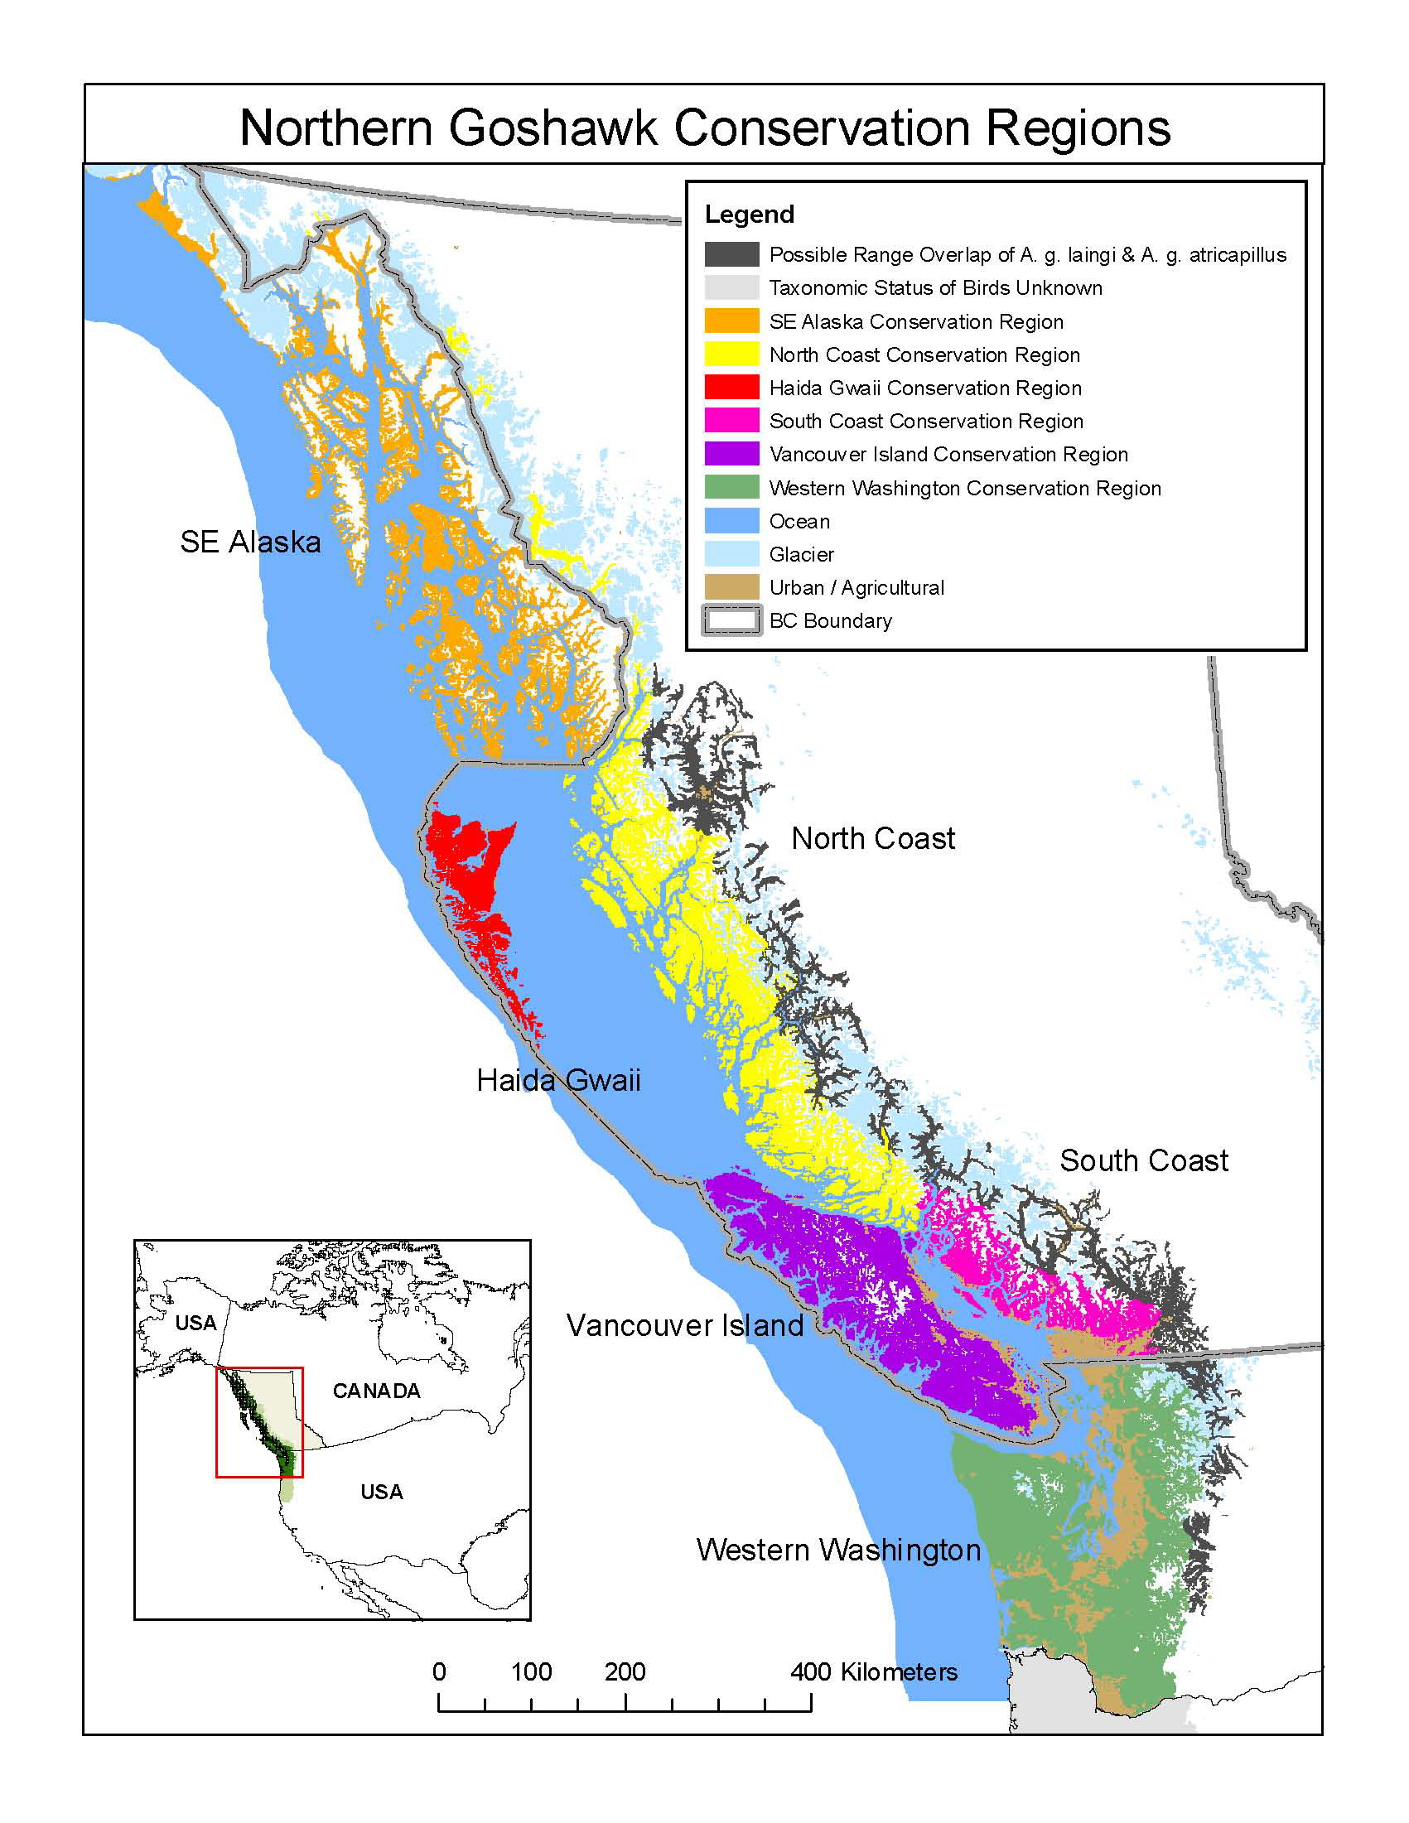

Figure 1. Range map for Northern Goshawk, Accipiter gentilis laingi. The British Columbia portion of the range of A. gentilis laingi reflects the distribution of wet Coastal Western Hemlock (CWH) biogeoclimatic subzones/variants and the Coastal Douglas-fir (CDF) biogeoclimatic zone. The recovery team has identified a zone (the drier variants of CWH on the coastal mainland) where A. gentilis laingi and A. gentilis atricapillus likely overlap. The recovery team used urbanization and agriculture as the best way to approximate the portions of the range of A. gentilis laingi that have been permanently lost, although the recovery team recognizes scattered pairs may be breeding within these areas. Four conservation regions (Haida Gwaii, North Coast, South Coast, and Vancouver Island) occur within Canadian jurisdiction (British Columbia) and two occur within U.S. jurisdiction (Western Washington and SE Alaska). The taxonomic status of individuals within coastal Oregon and California remains unknown.

