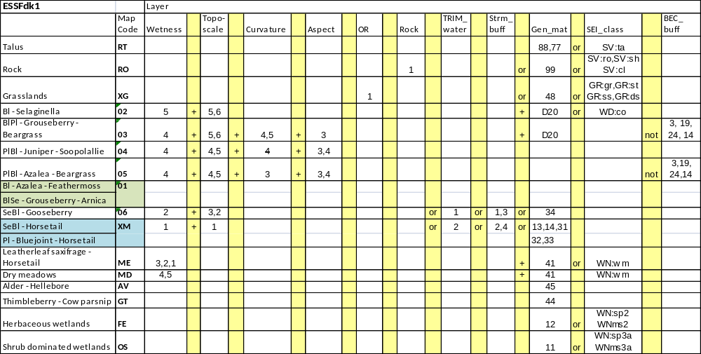
In the Northern extent of the Cranbrook TSA areas PEM’d as 01 are split in the data base into 50% 01 and 50% 04
In South extent of the Cranbrook TSA areas PEM’d as the following predicted site series are lumped with the approval of Del Meidinger, Mike Ryan and Deb MacKillop
01+05 = XA
03+04 = XB

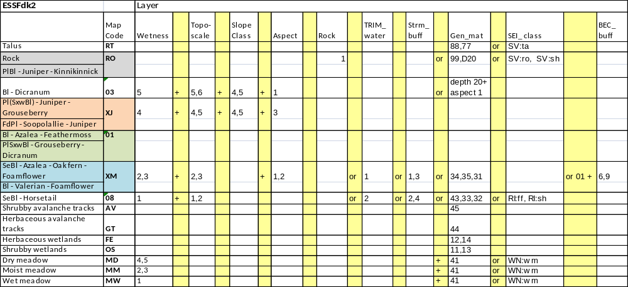
Throughout the ESSFdk2 all pixels classified as 01 are entered into the data base as 70% 01 +20% XJ +10% XM

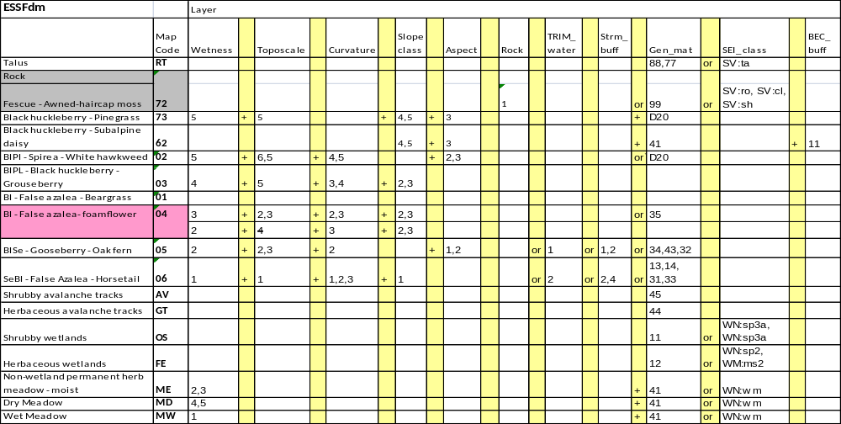
In the ESSFdm all pixels classified as 01 are entered in the data base as 70%01 +20%05+10%04

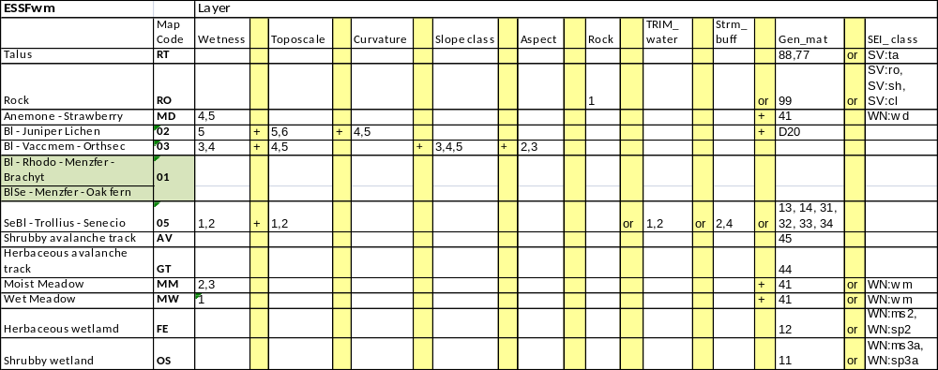
For the ESSFwm all pixels classified as 01 = 80%01 +20%03

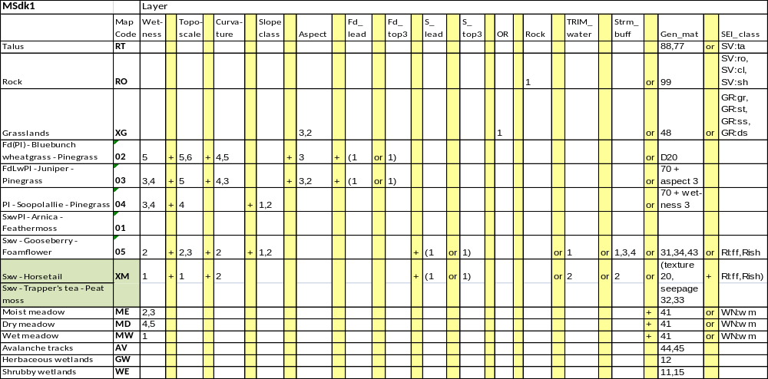
In the MSdk1 all pixels predicted as 01 are entered in the data base as 70%01 + 30%04
In the MSdk1 all pixels predicted as 04 are entered in the data base as 80%04 + 20%01

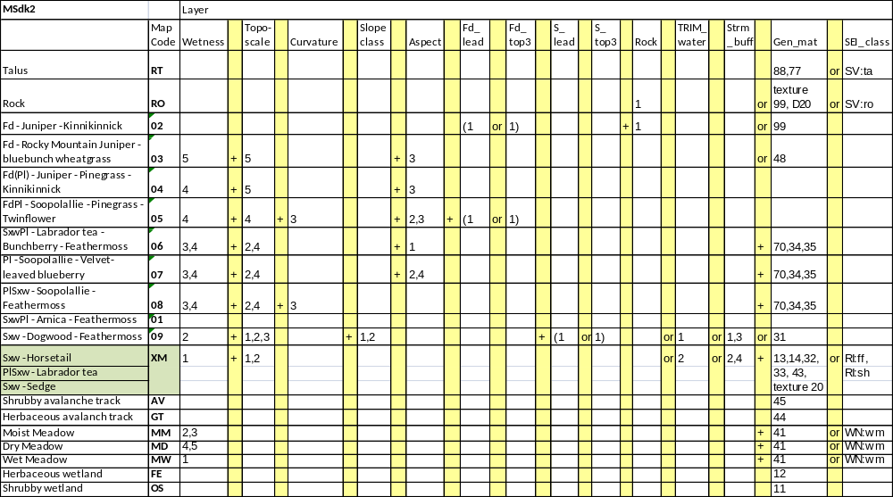
In the MSdk2 for the following lumps have been approved by Del Meidinger, Mike Ryan and Deb MacKillop
03 + 04 = XA
01 + 08 = XB

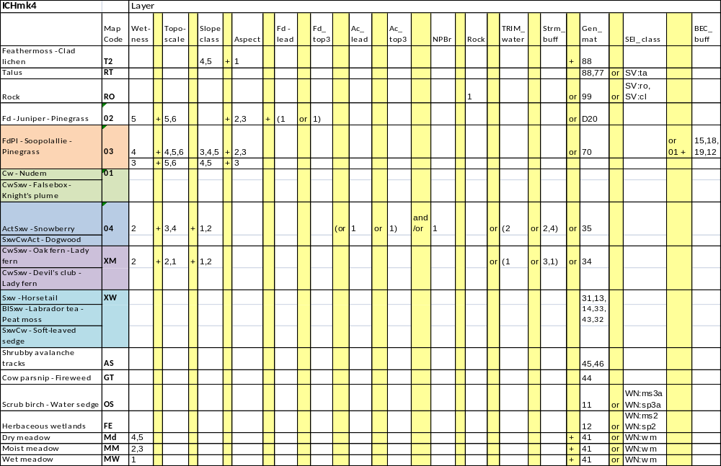

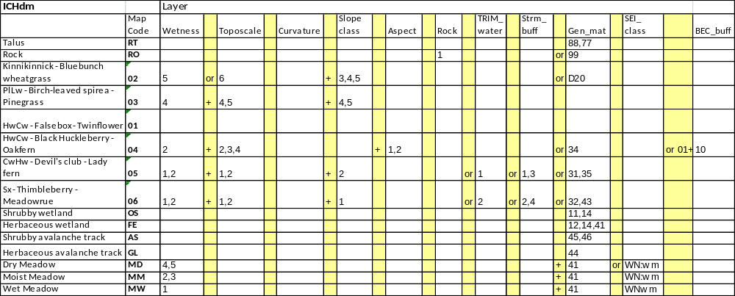

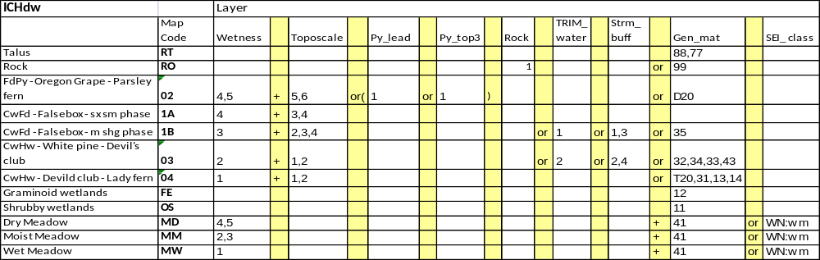

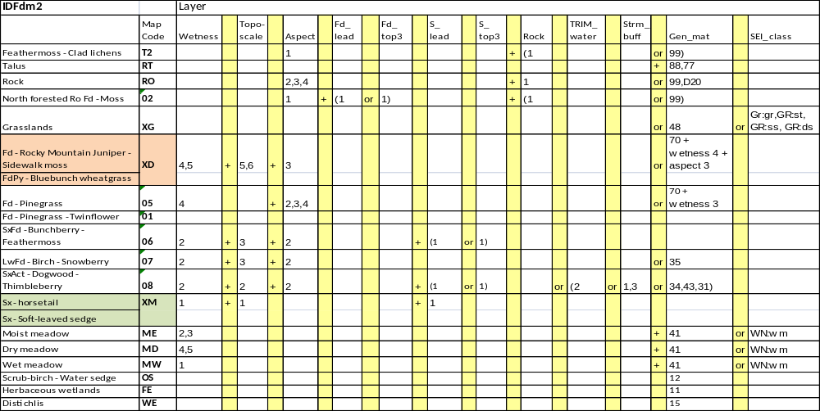
If map code = 01 + slope class =1 then map code = XB

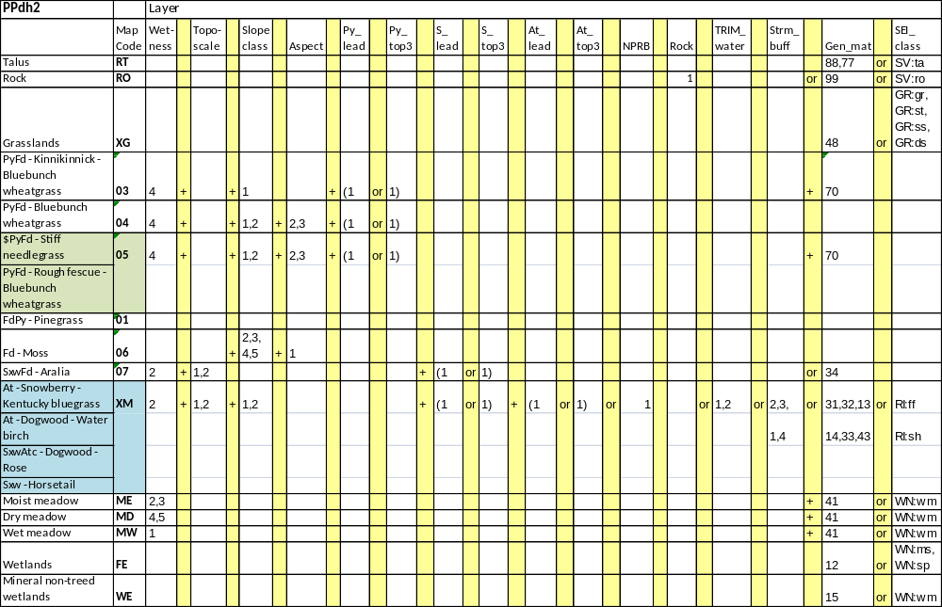
For all 01 data base shows 80% 01 + 20% 04

