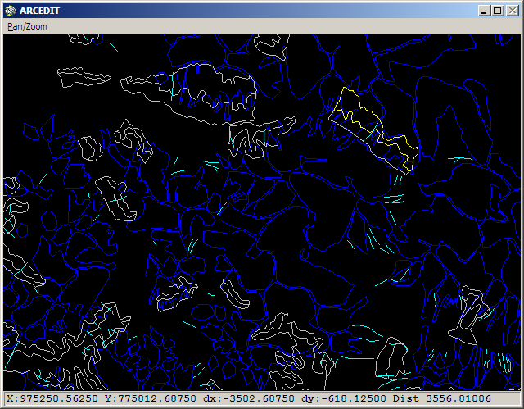

This is a screen image showing the following Central Coast datasets:

Dark blue – landply polygons
Light blue lines – avellin – lines - likely avalanche tracks
White polygons – avelply – polygons.. Attributes include Class, slide type, slideno, zone and process.
Yellow polygon has the following attributes: Class = R”ds, slidetype = ds, slideno=60, zone = initiation, process = (blank)

Does this make any sense?

