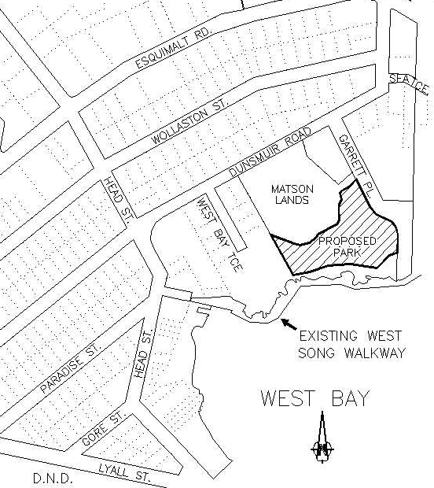
QUICK FACTS:

Park Area:
1.0 ha [2.5 acres]

Park Function:
Conservation/Interpretive Trails

Environmental Value:
Identified in the Sensitive
Ecosystems Inventory (CWS & BCEnv)

Habitat Value:
Remnant ecosystem providing habitat
for small mammals, birds, reptiles and invertebrates.
Maintenance:
Stewardship through a Conservation
Covenant.

Park Cost [Land Acquisition]:
Between $650 & $900,000

Market Value:
$2 - $3 Million [approximate].
An independent appraisal is in
progress.

Municipal Contribution:
A maximum of $500,000.
on a dollar-for-dollar matching basis

Time Frame:
May 1, 2000 is the deadline for
Assuring financial commitments.

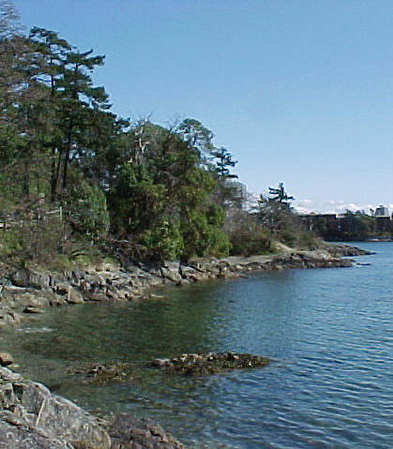

If funding is not in place by May 1st, the current proposal will be compromised and these environmentally sensitive lands may be lost to other forms of development allowed under the current zoning.

