ENVIRONMENTAL FEATURES

The Sensitive Ecosystems Inventory: East Vancouver Island and Gulf Islands 1993-1997 prepared by the Canadian Wildlife Service, B.C. Ministry of Environment, Lands and Parks, and the Habitat Conservation Trust Fund, identified this parcel as Polygon 268 which contains four ecosystems:

- Woodland/Terrestial Herbaceous - Polygon 268
5680 m² in area consisting of a mixture of Garry oak woodland and herb-dominated rocky outcrops.

- Woodland - Polygon 268A
3200 m² comprised primarily of Garry oak and arbutus with a well developed shrub layer of oceanspray.

- Woodland -Polygon 268B
7300 m² consisting of a mixed coniferous/broadleaf woodland comprised primarily of Garry oak and Douglas fir, with lesser amounts of bigleaf maple, Scouler's willow and Pacific yew. The shrub layer consists of oceanspray and Indian plum.

- Coastal Bluff - Polygon 268C
2500 m² of rocky outcrop in the littoral zone.
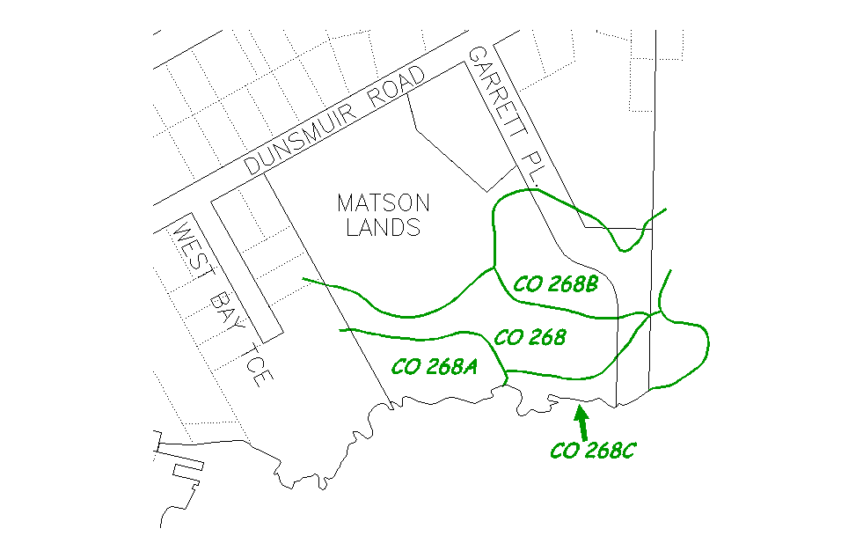

3
Wildlife observed or expected (*) to occur at the site
- Mammals: Mink; River Otter; voles*; shrews*
- Reptiles: Garter Snake; Alligator Lizard*
- Birds: Great Blue Heron; Hutton's Vireo; Kingfisher; Purple Martin; Cooper’s Hawk; Bald Eagle; finches; wrens; shorebirds; waterfowl
- Invertebrates: Propertius dusky wing* & many other species

WEST BAY
N
MATSON
LANDS

