CONSERVATION PARK CONCEPT

In recognition of the significance of this remaining sensitive ecosystem and waterfront greenspace, neighbourhood groups, the developer and the municipality devised the idea of designating this land as a 'conservation park'.

The lands would be permanently protected not only from future development but also from environmental degradation caused by inappropriate and unregulated use.

The intent of designating a 'conservation park' is to maintain a greenspace capable of supporting wildlife [amphibians, birds, butterflies, small mammals, and waterfowl] and providing aesthetic values for West Bay and Victoria's Inner Harbour.

The types of activities which would take place on this site are:
- restoration of native ecosystems;
- preservation and enhancement of wildlife habitat;
- nature interpretation.

The park would not include features normally found in parks such as assembly areas, playground equipment, sports fields and washrooms. The only development which may eventually take place is the construction of trails that would allow for nature interpretation and access to the West Song Walkway.

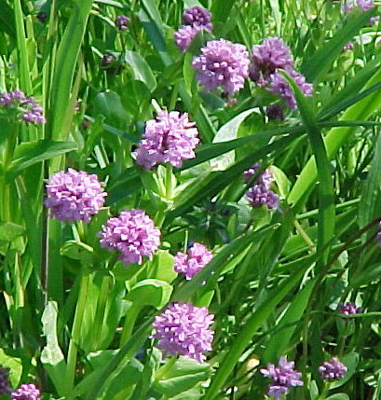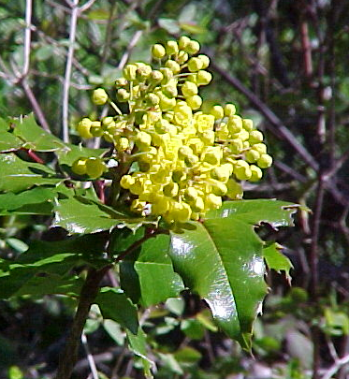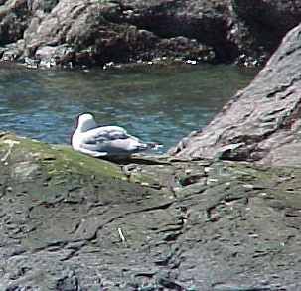Management and maintenance of the land would be done by the Municipality, a nature conservancy group, or a combination of agencies. Access to the site could be restricted to those persons carrying out conservation work [i.e. clearing non-native species; creating habitat enhancement], doing research, or conducting nature interpretation programs.
The Matson Lands Conservation Park would preserve
these features for the enjoyment of future residents
and visitors to the region.

