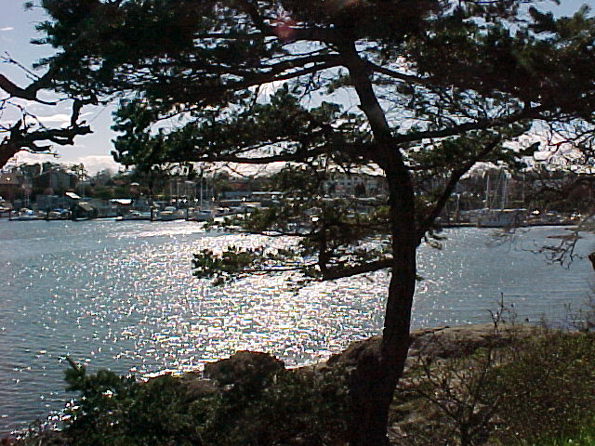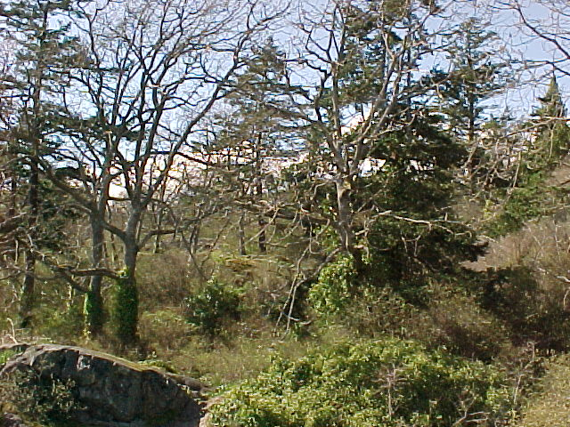
Please give your support, through funding, to help save this environmentally sensitive and regionally significant
greenspace from impending development.

