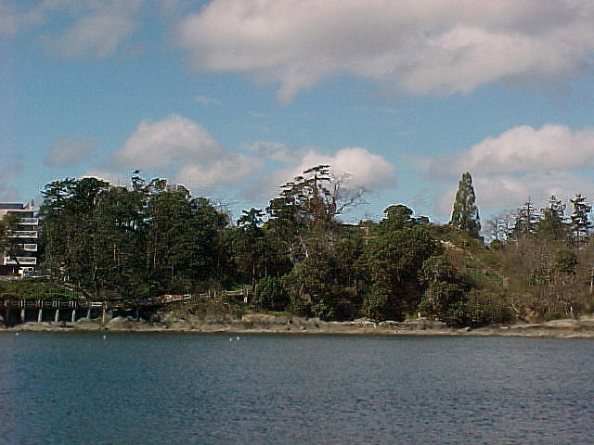

THE FRIENDS OF THE MATSON LANDS & PARTNERS

Care of : 944 Dunsmuir Rd. Esquimalt, B.C., V9A 3P1 Voice: [250] 381-8648

the Matson Lands

The site known as 'the Matson Lands' is a one hectare parcel fronting on West Bay near Esquimalt's eastern boundary. Although the upland portion of the property adjacent to Dunsmuir Road has historically been the site of the original Matson home and gardens, the steep bluff and woodlands below are still in their natural state and comprise a distinctive environmental feature fronting Victoria’s harbour entrance.

A recent development proposal, which would have affected much of the environmentally sensitive area, was the catalyst for the concept of converting this area to a Conservation Park. This concept came about through meetings between the Municipality, the Friends of Matson Lands, the West Bay Residents Association, Base Pacific Development Ltd., and the Provincial Capital Commission.

At the outset the local residents' goal was to save the entire property from development through the creation of a municipal park. After several facilitated meetings aimed at identifying all potential options, the concept of saving the bluff and coastal portion of the site as a conservation area, while allowing limited development on the upper portion, was accepted by all parties.

1
The next step in protecting this sensitive environmental area is securing funding.
The next step in protecting this sensitive environmental area is securing funding.

