

Signature: 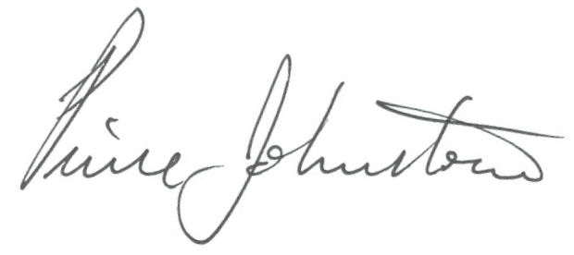

Date: March 23, 2015